Burger Behemoth (BB) Public Limited is a very successful chain of fast-food restaurants—with a large network of restaurants around the country, some of which are franchised, and others fully owned. Its brand has come to stand for standard, tasty, convenient and quick meals—and it has enormous customer loyalty among families with young children below 12, and also among busy executives on the road. However, growth is slowing, and greater health awareness among consumers has led to a general disenchantment with fast food. The CEO of BB is contemplating some new businesses that BB might enter. A candidate has emerged from internal discussion: the children’s theme park business.

After examining possible modes of inorganic growth into these businesses, one candidate has emerged for non-equity partnership—Mighty Monkey, an established player in the theme parks business. Should BB go for this non-equity partnership or should it instead go on its own?

Recall that the basic modes available for a company to expand into a new business are captured in what we call the “Growth tree” (see Section 4). At the first branch of the growth tree lies the choice between organic (internal) and inorganic (external) growth. Under inorganic growth the choice lies between non-equity alliances, equity alliances (including joint ventures) and acquisitions. These were the focus of Section 5. In this section we focus on comparing organic growth to these inorganic growth modes (see Figure 6.1).

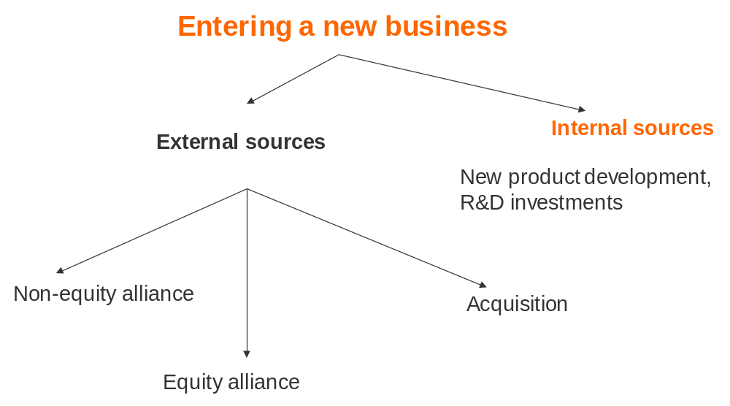
Figure 6.1 Growth tree

What is organic growth?
We refer to organic growth as the process by which a company enters a new business on its own—hiring, creation of a new project or business unit, repurposing an existing business unit, etc. If we think of the new business as possessing its own value chain, the goal of organic growth is to build up the resources and capabilities that this value chain entails, without recourse to other firms.

The choice of organic vs. inorganic growth is distinct from the traditional “make or buy” analysis, refers to a choice between making a product or service internally (and assumes that you have the capability to do this) or procuring it from an external supplier (who is also capable of producing the product or service, but at a different cost). This depends on a comparison of transaction costs and production cost differences (Section 9). Organic vs. inorganic growth refers to the choice between developing resources and capabilities needed to deliver a product or service to customers internally from scratch, or using external relationships to access such capabilities. The right analogy here is “build or buy”.

Comparing synergies and cost of entry for organic vs. inorganic growth modes
The diversification test we discussed in Section 4 required that V_{m}(AB) – C_{m}(B) > V(A), where V(A) is the standalone net present value of business A, V_{m}(AB) is the net present value of jointly operating both business A and B, under diversification mode m and C_{m}(B) is the cost of entering business B through governance mode m. In section 5 we discussed how V_{m}(AB) and C_{m}(B) vary for different inorganic growth modes. Here we analyze the conditions under which V_{m}(AB) and C_{m}(B) will increase or decrease for organic growth, also relative to that for external growth modes.

Synergies under organic growth are similar to those under M&A
The benefits of organic growth—which involves total control over the newly created, possibly synergistic resources and capabilities—can be approximated by the NPV that would accrue from acquiring the same assets inorganically, assuming zero cost of control (so that there is no premium for acquisition) and zero synergy independent costs of integration (i.e. the costs of restructuring and divesting unwanted assets, the costs of converting the acquired organization’s systems and processes to be compatible with the acquirer). This approach assumes that the synergy-dependent costs of integration (e.g. costs arising from the loss of that act like a marginal “tax” on the gains from synergies) are the same in organic growth and acquisition. This may not be a valid assumption if the prospective partner has a different culture and cultural difference matters for synergy extraction. Regardless, assuming no differences in the realized gain from synergies might be a useful first approximation, and one that we follow here. If the initial approximation is known to be inaccurate, then a second approximation can be made (based on the first) with an allowance in favor of organic growth.

For instance, the benefits from entry through building a new 100 unit production line in business B should be similar to the benefits from acquiring an existing 100 unit production line in the same business at its standalone value, with no cost of synergy-independent integration, assuming minimal cultural differences. The appendix to Section 2 provides the tools needed to value synergies.

Cost of entry under organic growth differs from that of inorganic growth
The costs of entry of organic growth are qualitatively different from those of inorganic growth. The costs of entry of organic growth can be estimated as they would be for any internal project for the company, with estimates of the investment required and time periods involved, appropriately discounted for the risks of the project. However, before we embark on this quantification exercise, it may be useful to do a qualitative check on whether we face conditions under which entry costs of organic growth are particularly cheaper than those of inorganic growth.

The starting point is to have clarity on the resource gap, i.e. those resources that are necessary to enter the new business but currently not present in the company. If no potential partner has them, you have no choice but to build them yourself. Assuming a potential partner has them, you face the choice of either inorganic or organic growth. Three factors influence this choice (see Figure 6.2).

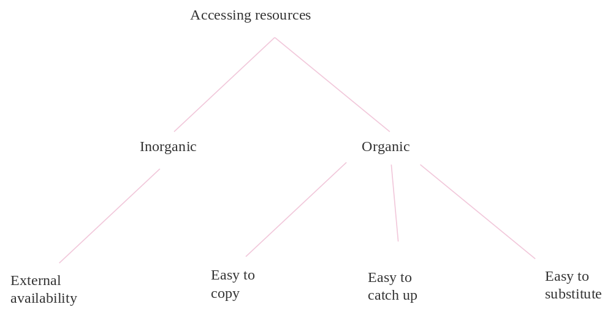
Figure 6.2 Key trade-offs in accessing resources

First, can you copy the resource? This will be harder if there are legal barriers (e.g. patents or protected technologies), the resource is present in people rather than codified (e.g. it may be difficult to copy customer friendliness), or prone to causal ambiguity (i.e. it is difficult to understand how to build the resource, for example, being innovative). To expand on the latter, there may be large uncertainties involved in building a resource. It may be impossible to fully specify which factors play a role in their accumulation process, e.g. if a large element of luck is involved. This is often true for knowledge based (e.g. intellectual property arising from R&D) and other intangible assets (e.g. brands or management skills). For instance, volumes have been written about Toyota’s production system, yet few have been able to replicate it.

Second, even if in principle it is possible to copy the resource, it may be difficult to catch up with the potential partner, who has begun building before you. This is referred to as first mover advantage (for them) or second mover disadvantage (for you). To expand on the drivers of second mover disadvantage, we can think of the resources and capabilities that underlie value chain activities in terms of their levels (“stocks”) and in terms of flows (“investments”). The levels of a resource may be relatively hard to change in the short run. Examples include reputation, loyalty, R&D capability, brand image, organizational culture. Flows represent investments in each period that add up to the stock of the resource (e.g. R&D spending, advertising budget, or training of employees). In financial statement terms, loosely speaking the income statement shows details of flows, while the balance sheet shows (some, but not all) resource stocks.

To compete, what one ultimately needs is the stock of resources, not the flow (think of brand vs. advertising expenditure). However, how easily others can recreate the stock through a flow of investments matters a lot for how sustainable the competitive advantage based on a stock of resources is. The characteristics of the process by which flows are converted into stocks determine if there is second mover dis-advantage in resource accumulation. If competitors can easily convert their flows (investments) into stocks (resources and capabilities), then it is hard to sustain competitive advantage by being the first to begin building the resource. Conversely, if you are a later entrant, you cannot hope to build (i.e. organic growth) if there are strong first mover advantages in resource accumulation created by the characteristics of the process, then you should explore options to buy (i.e. rely on inorganic growth) instead.

Dierickx and Cool (1989) set out several important properties of the resource accumulation process that affect this trade-off. The three properties listed below all describe conditions under which the conversion of investments (flows) into assets (stock) is faster, slower or uncertain. These are:
- Inter-connectedness of asset stocks: The rate at which investment in asset 1 converts into the stock of asset 1 increases with the stock of asset 2. Thus the rate of accumulating increments in an existing stock may depend not just on the level of that stock, but also on the level of other stocks. If a company has a strong brand, for instance, investments in building a sales force might bear fruit more rapidly. If a company has a strong R&D capability in making internet switches, investments in R&D for internet routers may generate returns more rapidly.
- Asset mass efficiencies: Indicates there are increasing returns to investing in the flows—the rate at which the flows get converted into stocks increases with the level of the stock. The phenomena of “success breeds success” and network externalities are instances of this property. For instance, a lab with good scientists finds it easier to attract even more good scientists.
- Time compression diseconomies: This implies that over and above the quantity of investment flows (investments), the time periods over which they are accumulated has a positive effect on asset stocks. This creates an “economy” for the first mover, and a “diseconomy” for the second mover. Thus a second mover who spends $10mn in the tenth year cannot catch up with a first mover who has been spending $1mn a year for 10 years. Imagine going on a crash training program, where you work out 10 hours a day for 3 months, hoping to become as fit as another who has spent 1 hour a day in the gym for the last 2 and a half years!

Discussions of the organic growth vs. inorganic growth decision often emphasize the notion that “if speed is important, organic growth is ruled out”. However, as we have pointed out here, the issue is not really speed but second mover dis-advantage. If others have the relevant assets, it is difficult for you to replicate them and there is a strong second mover disadvantage for you to try to build similar resources, then in effect you are forced to consider inorganic growth. You must however still consider the costs and benefits of inorganic growth set out in Section 5.

The third dimension when considering building a resource is whether you can substitute the potential partner’s resources for a different resource? The basic idea is that an external partner has a resource that facilitates new business entry. You may find that it is hard to copy or hard to catch up. A remaining possibility is for you to build a resource that differs from that of the potential partner but is functionally equivalent for entering the new business. Imagine for example that you want to enter the minivan market. The market leader uses an advanced technology of composite materials to produce the chassis. You find it impossible to replicate this technology. Instead you consider producing the chassis based on a more easily adoptable technology of steel stamping. Thus, instead of replicating the resource you aim to invent around it. The potential partner’s resource provides a useful template what to look for.

Combining these factors, the checklist in Table 6.1 below gives a qualitative indication of the conditions under which the costs of organic growth may be higher or lower. Note this gives an indication of the relative costs of organic versus inorganic options for deciding between these alternatives, not the absolute cost of organic growth.

Table 6.1 Deciding between inorganic and organic growth
Issue | If the answer is “Yes”, then favored growth mode is | Key Questions
External availability | Inorganic | Are partners available who have the resource?
Easy to copy | Organic | Are legal hurdles to copy the resource absent (e.g. patents)?
 |  | Has the resource been codified or is it independent of people?
 |  | Is it clear how to build the resource?
Easy to catch up | Organic | Do you own related resources and capabilities that can help in building the desired resources?
 |  | Are increasing returns absent when investing in these resources?
 |  | Are “crash investment programs” (e.g. trying to match $1mn/year over 10 years with $10mn in one year) likely to succeed?
Easy to substitute | Organic | Can you substitute the potential partner’s resource with a different resource?

When comparing organic growth with inorganic growth modes of different levels of equity (see Table 5.1) note that organic growth enjoys all the benefits of high equity levels but does not suffer many of the costs (e.g. no loss of motivation, control premium or synergy independent integration costs). The magnitude of second mover advantages relative to the costs of control, motivation losses and integration thus often determine this choice between “build” and “buy”.

Application: Burger Behemoth and Mighty Monky
Suppose you are the CEO of Burger Behemoth, whose diversification problem was described in the vignette at the beginning of this section. How would you conduct your analysis to decide between organic and inorganic growth?

The analysis continues from the previous section. We assume that (a) the synergy test has been passed, (b) the resource gaps have been identified, and (c) the best inorganic growth mode has been selected (i.e., non-equity alliance).

Step IV: Comparing with Organic growth mode
For Theme Parks, the benefits of organic growth would be proxied by the benefits of a hypothetical full acquisition (with zero premium and no synergy independent integration costs) of one of the theme park chains considered in Step III (which may or may not be the theme park chain chosen for strategic alliance). However, the qualitative analysis of the resources needed to operate in this business (physical infrastructure, content development and service delivery capabilities) is very likely to suggest that even if you could possibly replicate them there are strong second mover disadvantages. You have few related assets to leverage, there are increasing returns to investing in these assets, and crash programs will not work. Thus, organic growth is not really an option for BB. Thus, let’s say you conclude that net benefit inorganic > net benefit organic for Theme Parks. If BB enters Theme Parks, it will be through inorganic growth- specifically a non-equity alliance with an existing theme park chain.

<APPLICATION ENDS>

Basic facts about choice between organic and inorganic growth
- When entering new markets, companies are more likely to rely on organic growth the more related that market is to the companies’ existing markets. Having related resources makes it easier to replicate the necessary resources (see Table 6.1).

Common mistakes to avoid
- Do not ignore organic growth. True, few things create as much excitement in the corporate boardroom as M&A. Organic growth does not have the same glamour but can be a viable alternative. Considering organic growth is useful even if only to create a better M&A deal by developing a strong reference point for bargaining.

- Do not assume organic growth is easier than inorganic growth (because for instance there is no control premium or synergy independent integration). In fact, evidence suggests that failure rates of organic growth initiatives are comparable to those of M&As and alliances. A selective approach to the usage of each to match the resource gap being filled is most likely to succeed.

Frequently Asked Questions
- Discussions of the “organic vs. inorganic growth” decision often emphasize the notion that “if speed is important, one should use inorganic growth”.
a) Explain why this should be the case: why would inorganic growth necessarily be faster?
b) Even if it was faster, would inorganic growth be automatically preferable to organic growth?
a) The issue is not speed but the extent of “second mover disadvantage”, i.e., how hard it is for a later mover to copy an earlier mover’s competencies. In other words, even if organic growth was rapid, it can hardly beat acquiring a firm that already has the capabilities you need in terms of speed. Thus, in general it will take more time to replicate internally what somebody already has developed externally.
b) The cost of this difference in time needed to catch up has to be balanced against the cost of inorganic growth (e.g. control premium, post-merger integration, motivation loss).

Q2. How should I decide how to enter a foreign market?
The mode of foreign entry (e.g. greenfield investment vs. joint-venture) relies on the same criteria as above: external availability of partners who can fill the resource gap, ease of replication, and of catching up. It might be cheaper to build for some countries than others (e.g. those that are geographically or culturally close). FDI policies may rule out organic growth into others. Consequently, a companies’ entry mode varies by host country.

Academic background
For more on resources and their accumulation process, see:
Dierickx, I., & Cool, K. (1989). Asset stock accumulation and sustainability of competitive advantage. Management Science, 35(12), 1504-1511.
Barney, J. (1991). Firm resources and sustained competitive advantage. Journal of Management, 17(1), 99-120.
Helfat, C. E., & Peteraf, M. A. (2003). The dynamic resource‐based view: Capability lifecycles. Strategic Management Journal, 24(10), 997-1010.

For more on the choice between organic and inorganc growth, see:
Capron, L., & Mitchell, W. (2009). Selection capability: How capability gaps and internal social frictions affect internal and external strategic renewal. Organization Science, 20(2), 294-312.
Capron, L., & Mitchel, W. (2012). Build, borrow, or buy: Solving the growth dilemma. Boston, USA: Harvard Business Review Press.
Moatti, V., Ren, C. R., Anand, J., & Dussauge, P. (2014). Disentangling the performance effects of efficiency and bargaining power in horizontal growth strategies: An empirical investigation in the global retail industry. Strategic Management Journal.

Helfat, C. E., & Lieberman, M. B. (2002). The birth of capabilities: Market entry and the importance of pre‐history. Industrial & Corporate Change, 11(4), 725-760. Brice, D. J., & Winter, S. G. (2009). A general interindustry relatedness index. Management Science, 55(9), 1570-1585. Lee, G. K., & Lieberman, M. B. (2010). Acquisition vs. internal development as modes of market entry. Strategic Management Journal, 31(2), 140-158.
On organic growth: Day, G. S. (2007). Is it real? Can we win? Is it worth doing? Harvard business review, 85(12), 110-120. Van der Panne, G., Van Beers, C., & Kleinknecht, A. (2003). Success and failure of innovation: a literature review. International Journal of Innovation Management, 7(03), 309-338. On alliances: Kale, P., Dyer, J. H., & Singh, H. (2002). Alliance capability, stock market response, and long term alliance success: The role of the alliance function. Strategic Management Journal, 23(8), 747-767. Kale, P., & Singh, H. (2009). Managing strategic alliances: What do we know now, and where do we go from here? Academy of Management Perspectives, 23(3), 45-62. On M&As: Pautler, P. A. (2003). Evidence on mergers and acquisitions. Antitrust Bulletin, 48, 119-221. King, D. R., Dalton, D. R., Daily, C. M., & Covin, J. G. (2004). Meta‐analyses of post‐acquisition performance: Indications of unidentified moderators. Strategic management journal, 25(2), 187-200.

